

Product Description

The Ei100C is an Ionisation Smoke Alarm that runs on a 9V alkaline battery (supplied with the alarm).

Ionisation smoke alarms operate on the principle that electrical current flowing between electrodes in an ionization chamber is reduced when smoke particles enter.
Ionisation technology gives a rapid response to fast flaming fires

The Ei100C is easily installed and comes supplied with all necessary screw fixings.

The Ei100C is fitted with a warning flag that pops up when the battery is removed. This prevents the cover from closing when there is no battery fitted to the unit. When the battery is being installed or changed, this flag must be held down while gently pushing the battery into the battery holder.

When the battery is first connected, the alarm may sound for 2-3 seconds – this is normal and means that the battery is connected correctly

Operation

- Interconnect up to 12 other alarms (9V ionisation, optical or heat) when one senses smoke, all alarm. Helps ensure warning will be heard throughout the house
- The smoke detector will activate the built in sounder upon sensing smoke particles

- The smoke detector will automatically reset itself and silence the sounder when smoke particles are no longer present in the sensing chamber

- The built in sounder will provide a minimum sound output of 85dB at 3m

- The smoke detector has a built in warning flag to prevent installation of the detector without a battery fitted

- The “Test” button will perform a self test and sound the horn (it may take up to 10 seconds)

- The smoke detector will emit a beep every 40 seconds to indicate that the battery back up is depleted and needs replacing

9V BATTERY POWERED

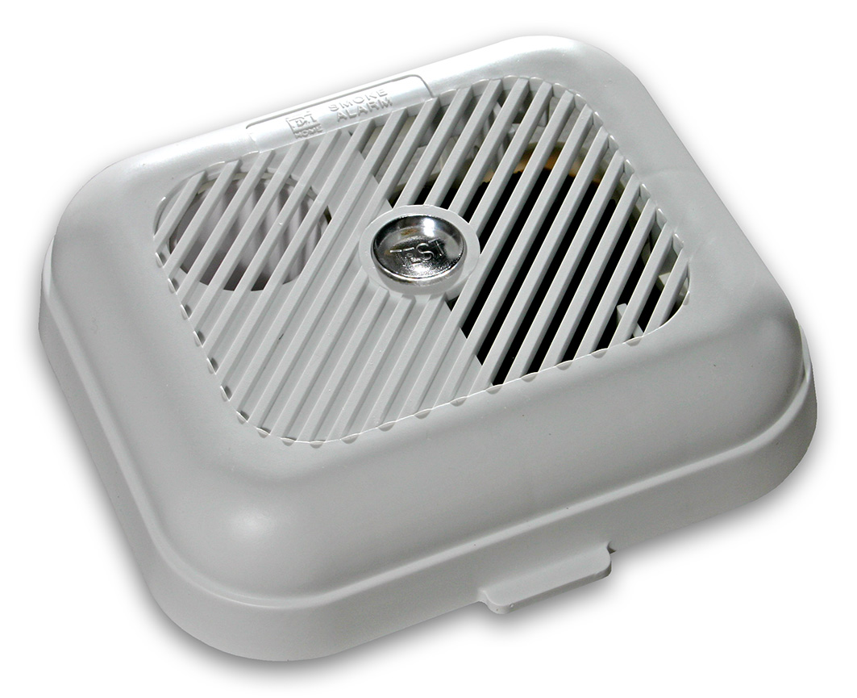

Model Ei 100C Ionisation

High sensitivity – responds to all standard fires

Dual Ionization chamber - quick response fast flaming fires
- Battery powered – 9V alkaline (supplied)
- Interconnect up to 12 other alarms
- Needs no wiring
- Missing battery indicator
- Low battery warning
- Built in sounder
- Test button
- Kitemarked to BS5446-1:2000
- 5 year guarantee

Model Ei100C Ionisation

Installation & Placement

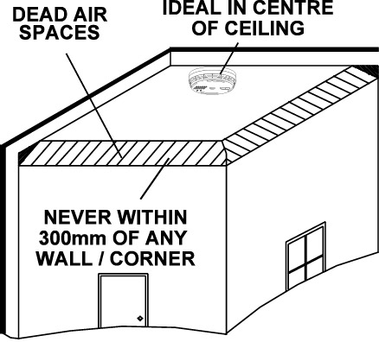

Alarms should be placed in accordance with the general guidelines shown in the diagram above. These recommendations are based on the problem of areas of “dead air” close to corners of rooms and apexes of ceilings, which could result in the prevention of smoke reaching the smoke detector

Please consult the Instruction Leaflet supplied with the Ei100C for detailed instructions as to how to correctly install and position the smoke detector

Important Precaution:
Do not install the actual smoke/heat alarm itself in new or renovated buildings until all work is completed (including floor coverings) and the building has been fully cleaned. (Excessive dust and debris from building work can contaminate the smoke chamber and cause problems, and it will also invalidate the guarantee). If it must be installed, cover it completely, particularly around the edges, with a dust cover (eg. a plastic bag), until all cleaning is finished..

Technical Specification

Sensor Ionisation, uses electrically charged ions that will react
to smoke particles

Sensitivity: Complies with BS 5446 Part 1: 2000

Source: Americium 241

Airspeed: Essentially immune to the effect

of airspeed.

Button Test: Simulates the effect of smoke and

checks chamber, electronics and horn.

Supply Voltage: 9V battery

Alarm: Piezoelectric-horn

in unit

Alarm Sound Output: 85dB (minimum) at 3m

Temperature Range: 0 to 40°C

Humidity Range: 0% to 90% Relative Humidity

Fixing: Screw fixings supplied

Plastic material: UL94HB flame retardant

Dimensions: 140x120x45 mm

Weight: 174 gram

Warranty: 5 year (limited) warranty

Approvals: Kitemarked to BS5446-1:2000, CE Approved

Specifications are subject to change

