Product Information

Product: Small foam extinguisher

Type: 2lt AFFF portable fire extinguishers

Application: Ideal for: cars, vehicles, taxis, heavy goods vehicle cabs, kitchen, caravan, small boats, workshops etc.

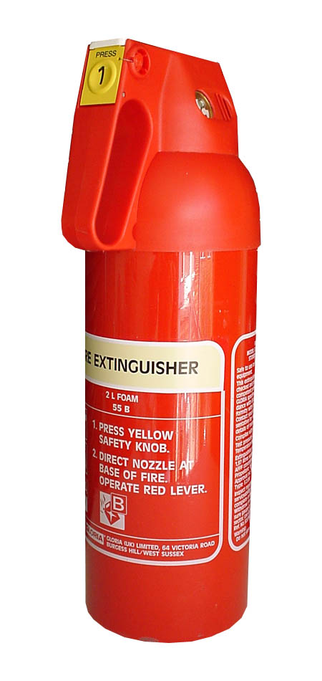
Features:
- Compact design
- Patented safety strap
- All-purpose extinguisher
- Ergonomically designed
- Easy to use
- Handle design

Benefits:
- Very light weight
- Controlled discharge
- Completely refillable
- Supplied with pressure gauge
- Very cost-effective

Technical Data

Model | Capacity | Type | Weight of charged extinguis-her | Extinguis-hing agent | Volume of extinguis-hing agent | Working pressure | Discharge Times | Range of jet horizontal | Temperature range | Height mm | Width mm | Depth mm
S2LW | 2lt | Stored pressure | 3.5kg | AFFF | 0.03lt | 15 bar | 20 sec. | >2m | 0°C to +60°C | 365 | 152 | 110

THE SMALL POWDER EXTINGUISHERS have been specifically designed with the vehicle market in mind. It is especially useful for multiple fire risk situations involving moving vehicles and is a truly versatile, compact and very useful fire extinguisher.

    Model |  |  |  | 
S2LW | 5A | 70B

