The EvacSill is an emergency escape system. Please note:
- It should only be used by able-bodied people capable of climbing over the window sill and descending on the emergency escape ladder unaided. The ladder is therefore only suitable for mobile people aged 10 to 60 years of age.
- It should only be deployed in an emergency.
- It should not be used as an access device.
- Only one person should be on the ladder at any one time.
After the deployment, the ladder must be re-packed by the manufacturer. To this purpose the used ladder component within the system must be sent to
Safelincs ltd
Unit 1, Farlesthorpe Road
Alford
LN13 9PS

You should, however, familiarise yourself with the product.
You should find underneath the sill, or in the information pack of the builder, a self-adhesive, glow-in-the-dark sticker which you can stick on top of the sill. This sticker offers instructions of how to remove the sill.
Underneath the sill is also an instruction board showing the deployment of the EvacSill emergency escape system.
Please keep this manual in a safe place and pass to the next person living in this house after you!

Deployment of the EvacSill escape system
1) Place your hands wide apart on the inner window sill and pull it carefully towards yourself without jamming it. Remove the sill altogether
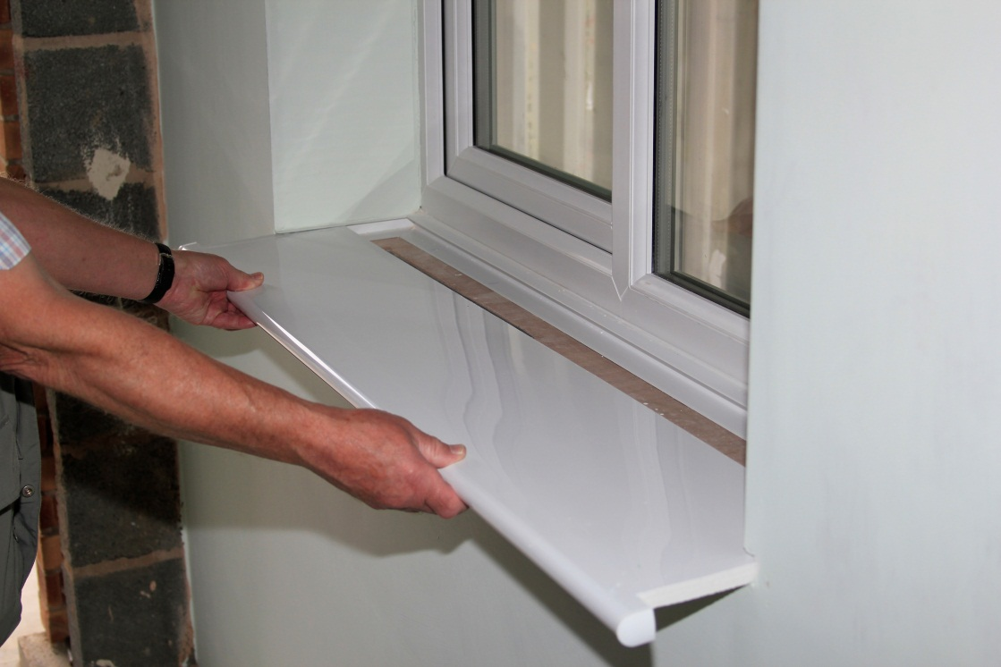

2) open the window fully
3) Lift the ladder pack out of its box
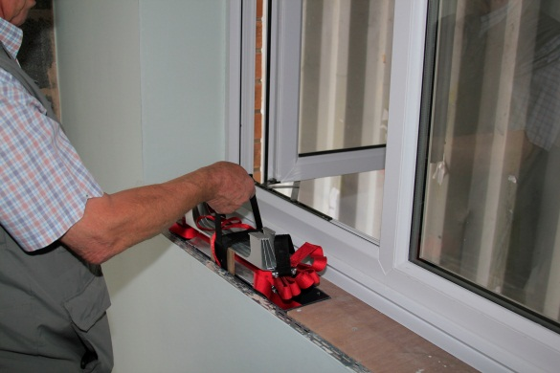

4) Hold the ladder pack out of the window as shown and let it drop. The ladder will open up by itself.
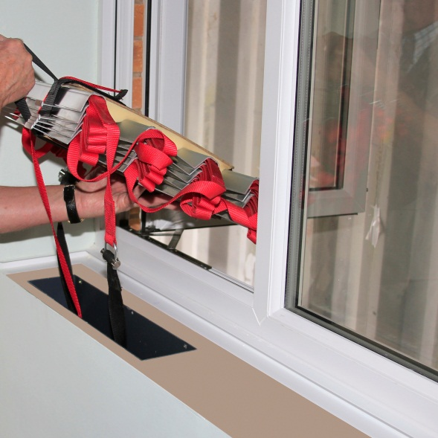
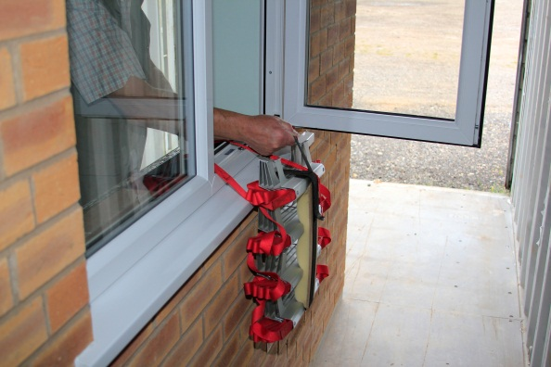
5) Check that the ladder is correctly unfolded. If there is any entanglement, pull the ladder up and disentangle it before using it.
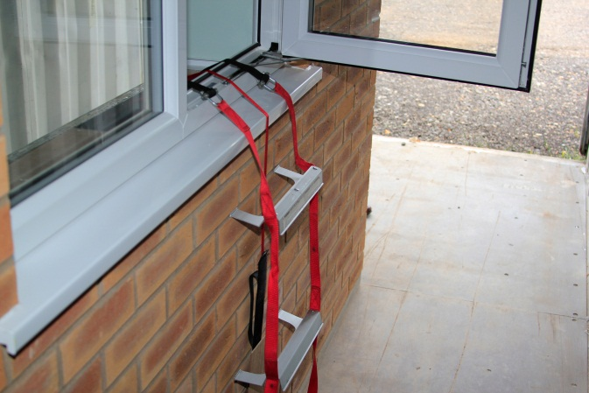
6) Lift one leg over the wall underneath the window and straddle the window sill. While doing this you must keep hold of the window frame with BOTH hands at all times.
7) Place the foot on a rung. Make sure you have found a solid hold.
8) Carefully place your second leg outside and place its foot on a rung as well. Lean into the room while doing this to avoid losing balance! DO HOLD YOURSELF on the window frame or the wall all the time
9) Carfully place first one hand on the ladder structure, then the other
10) Carefull climb down the ladder, keeping your body as close to the ladder as possible
11) If further people are using the ladder after you, stand at the bottom of the ladder and stabilise the end of the ladder for them if it is safe doing so. Do not endanger yourself.

Please note: parents should climb before their children, as
a) a child is more likely to climb the ladder if a parent is already outside
b) you can stabilise the ladder for the child from below

